NAME : S Surender

REG NO:192426007

Set 13: Geographic Data

Question 1: Map Chart

Aim
To create a map chart showing the distribution of cities and label its elements.

Procedure
- Load ggplot2 and create the data frame (with assumed longitude and latitude).
- Plot cities as points on a longitude-latitude map, sized by population.
- Add city labels, title and axis labels, then display the map.

Code
library(ggplot2); library(gridExtra)
d <- data.frame(City=c("City A","City B","City C"), Population=c(500000,700000,600000), Temp=c(75,68,80),
Elevation=c(1000,800,1200), Lon=c(77,80,73), Lat=c(13,19,26)) # lon/lat assumed
m <- ggplot(d, aes(Lon, Lat, size=Population, label=City)) + geom_point(color="red") + geom_text(vjust=-1.5, size=3) + labs(title="Distribution of Cities", x="Longitude", y="Latitude")
print(m)

Output
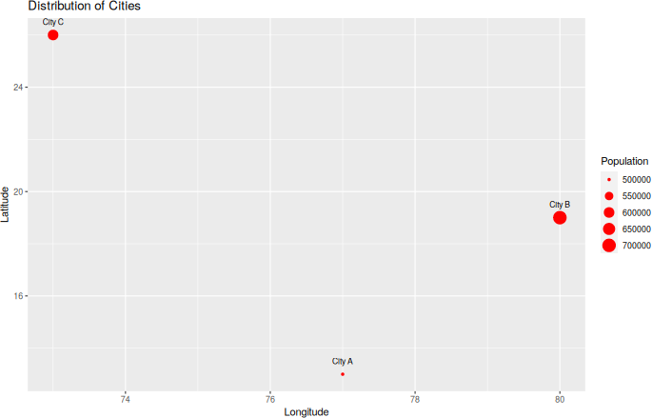
Fig 1: Map chart of cities

Result
The map chart was created. Each city is a labelled point; larger points mean larger population (City B is the biggest).

To explore the relationship between average temperature and population size using a scatter plot.

Procedure
- Plot Temperature on the x-axis and Population on the y-axis.
- Add city labels and a trend line.
- Find the correlation with cor() and interpret it.

Code
- <- ggplot(d, aes(Temp, Population)) + geom_point(size=4, color="blue") + geom_smooth(method="lm", se=FALSE) + geom_text(aes(label=City), vjust=-1)
+
labs(title="Temperature vs Population", x="Avg. Temperature (F)",
y="Population") print(s)
cat("Correlation:", round(cor(d$Temp, d$Population), 2))

Output

Console output:
Correlation: -0.58
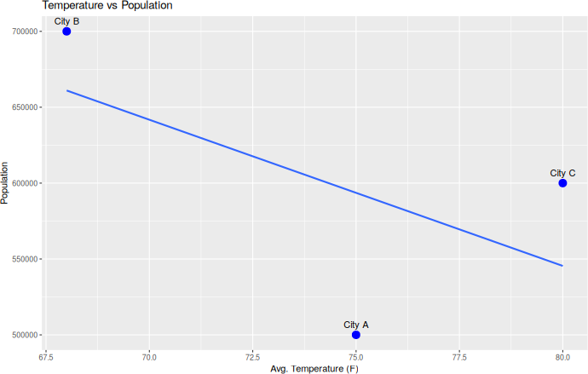
Fig 2: Scatter plot – Temperature vs Population

Result
The scatter plot was created. Insight: the correlation is -0.58 (negative), so the hotter cities (C: 80°F, A: 75°F) have smaller populations than the coolest city B (68°F, 700000). With only three cities this is a weak indication.

To build a labelled table displaying the geographic data of each city.

Procedure
  - Select the City, Population, Temp and Elevation columns.
  - Print the data frame and draw it as a table using tableGrob().

Code
print(d[, 1:4])
- <- tableGrob(d[, 1:4], rows=NULL) grid.arrange(t)

Output

Console output:
City Population Temp Elevation
1 City A | 500000 75 | 1000
2 City B | 700000 68 | 800
3 City C | 600000 80 | 1200

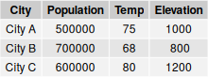

Fig 3: Table of geographic data

Result
The table displaying city, population, average temperature and elevation was created with labelled column headings.

To combine the map chart, scatter plot and table into one dashboard for exploring the geographic data.

Procedure
  - Use the map (m), scatter plot (s) and table (t) from the earlier questions.
  - Arrange all three in one panel using grid.arrange().

Code
grid.arrange(m, s, t, ncol=2)

Output
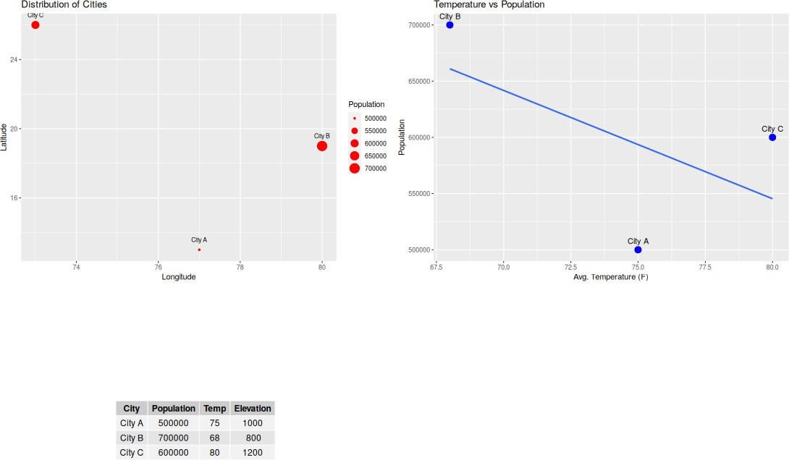

Fig 4: Dashboard (map + scatter plot + table)

Result
The dashboard combining the map chart, scatter plot and table was created in R.

